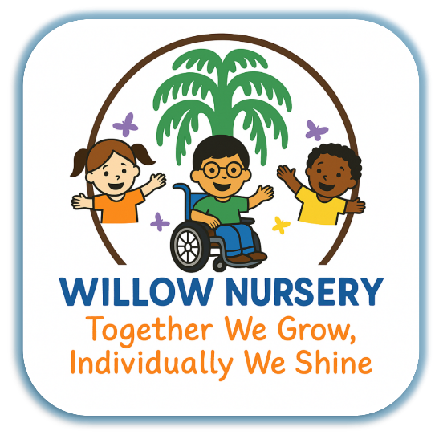

Willow Nursery and Best Start Family Hub
Nursery Statement
Willow SLT
2025-2026
Willow nursery is part of Best start family hub with a specialist in SEND provision. It has three age-related rooms, and an additional resource provision for children with a diagnosis of ASD. Admission to this room is through the Under 5s specialist nursery panel, to which professionals working with a child can apply.
Staff at willow are highly trained and have access to ongoing training throughout the year.

Intent:
Our intention at Willow is to make learning fun through our play-based curriculum following the EYFS. We maximise every child's potential by supporting them to be Active Independent Learners who can communicate through a variety of ways. We want our children to build on strong foundations in academics so that they can be lifelong happy and curious learners. We strive to create a learning environment that builds and supports children’s curiosity, confidence, and individual competencies, regardless of background or circumstances. Our aim is to encourage enthusiastic independent learners who will thrive and maximise their potential on there lifelong journey of learning. We do this by working alongside parents, carers and other professionals
Children starting at Willow enter in to the EYFS learning journey, we encourage a positive learning journey by developing physically, verbally, and cognitively and emotionally embedding a positive attitude to learning. Our Intent at Willow is to take into consideration the starting and needs of all children in the setting as they begin their journey of learning.
All children have access to a curriculum that is broad, balanced and diverse, preparing them for now and the future.
We follow the children’s interests, individual needs, and experiences, we also plan and provide exciting opportunities throughout our curriculum to support and enable learning and development.

Skilful Communicators:
We aim to encourage all children to connect with others, through language and play, ensuring our nursey is rich with vocabulary in the environment. All staff are trained in ECAT (every child a talker). We also offer Early Talk Boost. All staff use a total communication approach, supporting communication using gesture, signs, and symbols, depending on the needs of the child. We provide a language rich environment and all staff have received training in supporting children’s developing communication skills.

Active Independent Learners:
We aim to ensure that all children will enjoy coming to nursery and be confident in their relationship with their keyworker enjoy learning and developing new skills and enhancing those they already have. We support children to be school ready

Secure and confident Learners:
Our aim at Willow is that when every child leave’s Willow they will have the desire to learn, will be motivated and confident to seek out new experiences and ask questions and find the answers. We want our children to be enquiring, risk takers, who are well prepared for their start at primary school.

Implementation:
At Willow SEND FWC nursery we follow the Early Years Foundation Stage Framework. This is made up of Four Principles:

Enabling Environments
The Environment plays a key role in supporting and extending children’s development and learning
Positive relationships
Children learn to be strong and independent from a base of loving and secure relationships with parents/carers and keyperson
A Unique Child
Every Child is a competent learner who can be resilient capable and self assured

Learning and Development
A firm foundation in the prime areas is important for children’s overall learning and development. Children develop and learn in different ways and at different times, all areas of learning and development are significant and interconnected. The care of all children including those with special needs and disabilities is covered in the framework.

Areas of Learning:
At Willow all areas of the EYFS curriculum are represented throughout the learning environment.
Characteristics of Effective learning: (CAP)
- Creating and thinking critically
- Active Learning
- Playing and Exploring
Prime areas in the EYFS are given priority. These consist of.
- Personal, Social and Emotional Development
- Communication and Language
- Physical Development
Specific Areas:
- Literacy
- Mathematics
- Understanding of the World
- Expressive Art and Design

Early Communication:
Willow gives priority to developing children’s communication skills in all learning opportunities. We use the following for all children Mainstream and SEND where needed.
- Visual timetable
- Now and next board
- Makaton
- British Sign Language
- PECS
- Pre Braille
- Visual cards
Children are taught a Makaton sign of the week.
The learning environment in each of the rooms is designed so that children can play cooperatively and wheelchair users and those with mobility or visual impairments can access all areas of the learning environment without difficulty.
Each room has access to a quiet space which we call the Black and White Area so that children with sensory needs are not triggered by bright colours and it helps promote a sense of calmness.
Staff ask open ended questions to promote critical thinking and sustained shared thinking.

Literacy and Maths:
At Willow we teach children
- Letters and Sounds stage 1 phonics sessions
- Rhyme/ song of the week
- Core books
- Opportunities to practise literacy and Maths skills in the enabling environment of the nursery independently.
- Access to mark making materials in all areas of the nursery, specific areas in each room for Mark making
- Areas with cushions and soft furnishings for children to feel cosy and read books independently or with an adult/ access to a variety of big books
- Access to Role play areas, small world area, puppets and a variety of books in the book area.
- Independent access to Maths resources, such as shape space and measure.
- Maths counting opportunities such as one to one correspondence, subitising, counting to 5,10,20. Numbers as labels.

EYFS play Based curriculum.
- Children are expected to select resources independently to play with an adult will support them to tidy them away.
- Continuous provision at Willow promotes active learning.
- Each room at Willow has a routine they follow which supports children to feel safe and autonomous in their learning, which promotes self- regulation
- We follow children’s interests and facilitate a seasonal calendar to enhance children’s learning IE: by providing provocations, visitors, visits, celebrations, festivals.
- One to On Interventions, Yoga, Sports coach, Superpower play enhancing child self-regulation
- Facing onto the iconic Wembley Stadium Arch, we provide a rich outdoor area with opportunities for children to climb and develop their physical skills, to dig in the garden and grow vegetables, search for bugs, harvest fruits and vegetables

Impact:
Children who have attend Willow Nursery are curious about the world and eager to continue their learning journey into primary school.
Children at the nursery make progress and leave the nursery, ready for reception in school. They are able to communicate having developed a wide vocabulary and they show a willingness to continue having learnt key skills, knowledge and dispositions.
Children develop personal and social skills in being kind and respectful to each other and they understand the difference between right and wrong. The impact of our curriculum ensures that children are prepared to be Active Independent Learners who understand the importance of looking after the world around they are growing up in.
ama
Data:
We collect data to find out at what stage of development our children are, what is the rationale behind it and how we can support them in their journey of learning.
First, we ask key workers to complete the tracking sheet for each child, six weeks after their arrival at the nursery and then every term. We have set a date in our termly plan when those tracking sheets are due to the Senior Leadership Team. Then SLT carry out some moderation sessions with staff where we choose some children to discuss their tracking sheets with all the staff team to make sure the key worker’s judgment is a true picture of child’s development. After the Nursery Manager analysis, the data for different categories in different age group/rooms such as boys, girls, SEND, the dominant ethnic group.
For example, from the analysis we can judge how the boys are doing in baby room in the primary areas.
We use this result to plan activities and improve the outcomes for children.

